

**FINAL ASSIGNMENT**

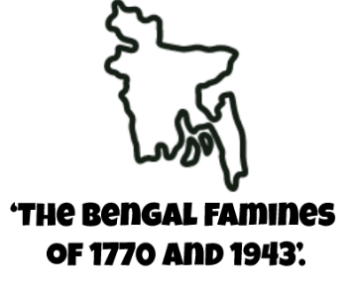

**Course: BANGLADESH HISTORY**

Course Code: HIS101

Section: 18

Submitted to:

Ashit Boran Paul (ABP1)

Lecturer

Department of History and Philosophy

**NORTH SOUTH UNUVERSITY**

Submitted By

|  |  |
| --- | --- |
| Name: Md Aman Ullah | ID: 1610688030 |

**INTRODUCTION**

Famine refers to extreme shortage of food primarily due to supply shortages and less frequently due to in-efficient allocation of the existing supply combined with a policy failure to tackle the situation. Bengal has had its fair share of famines in the past including 1770, 1783 and 1897, but the most recent one, of which often British Raj is accused of was in 1943. The famine led to the death of around 3 to 4 million Indians, either due to starvation or due to famine related diseases. Winston Churchill’s comment on the famine, reflects the sheer neglect of British Government towards Indians and their plight: “I hate Indians. They are a beastly people with a beastly religion. The famine was their own fault for breeding like rabbits.” The Bengal famine of 1943 was a [famine](https://en.wikipedia.org/wiki/Famine) in the [Bengal province](https://en.wikipedia.org/wiki/Bengal_Presidency) of [British India](https://en.wikipedia.org/wiki/British_Raj) during [World War II](https://en.wikipedia.org/wiki/World_War_II). The famine of 1770 was one of the greatest calamities in Bengal's history. It carried off between one sixth and one third of the population. Coming in the wake of the Maratha invasions and the unparalleled revenue exactions of Siraj-ud-doula, Mir Qassim, and the East India Company, the famine must have left many Bengalis wondering whether a darker yuga (age) or the wrath of the deities had descended on their society. Despite the high mortality and suffering, there were few signs that people blamed human agency for the absence of relief.

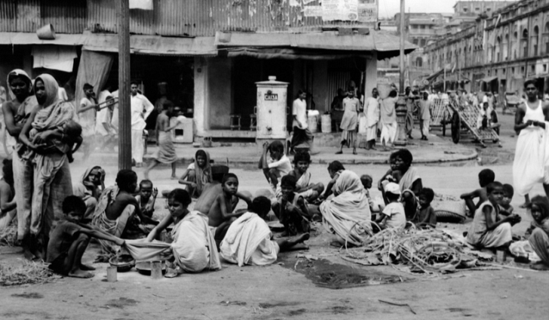A deplorable starvation influenced the lower Gangetic Plains of India including the districts of Bengal and Bihar somewhere in the range of 1769 and 1773 where 1/third of the populace died. An expected 10 million individuals kicked the bucket of starvation and starvation activated plagues that additionally influenced the areas of Assam, Odisha, Jharkhand and Bangladesh. As in the ensuing starvations, there was little savagery, in any event, when the East India Company wouldn't bring down its income requests on the survivors. That refusal, we may deduce, constrained the capacity of income payers to enjoy their wards, as was standard, as they battled to continue development of abandoned fields and pull in swaps for perished workers. Generally Bengal has been, comparative with different pieces of India, safe to enormous scope disappointments of the storm. The main significant starvations in Bengal in the previous three centuries have been in 1770, 1866, and 1943-44. For the most part adequate precipitation and low changeability, comparative with different pieces of the subcontinent, are unique highlights of Bengal's atmosphere. The western locale of Bankura, Birbhum, Burdwan, and Hugli normal somewhere in the range of fifty and sixty crawls of downpour every year while the focal and eastern regions get more. Prior to the 1770 starvation, there was a British accord that Bengal's economy was crumbling.

**IMPORTANCE OF THE TOPIC**

FAMINE OF 1943

The Bengal famine of 1943 was the only one in modern Indian history not to occur as a result of serious drought, according to a study that provides scientific backing for arguments that Churchill-era British policies were a significant factor contributing to the catastrophe.

Researchers in [India](https://www.theguardian.com/world/india) and the US used weather data to simulate the amount of moisture in the soil during six major famines in the subcontinent between 1873 and 1943. Soil moisture deficits, brought about by poor rainfall and high temperatures, are a key indicator of drought.

[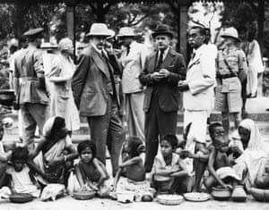](https://www.theguardian.com/world/2019/mar/29/winston-churchill-policies-contributed-to-1943-bengal-famine-study#img-2)However, the [1943 famine in Bengal](https://www.theguardian.com/books/2011/sep/23/three-famines-starvation-keneally-review), which killed up to 3 million people, was different, according to the researchers. Calcutta, against the wishes of the colonial British administration.

“This was a unique famine, caused by policy failure instead of any monsoon failure,” said Vimal Mishra, the lead researcher and an associate professor at the Indian Institute of Technology, Gandhinagar.

[](https://www.theguardian.com/world/2019/mar/29/winston-churchill-policies-contributed-to-1943-bengal-famine-study#img-3)But the Nobel prize-winning economist Amartya Sen argued in 1981 that there should still have been enough supplies to feed the region, and that the mass deaths came about as a combination of wartime inflation, speculative buying and panic hoarding, which together pushed the price of food out of the reach of poor Bengalis.

Rice stocks continued to leave India even as London was denying urgent requests from India’s viceroy for more than 1m tonnes of emergency wheat supplies in 1942-43. Churchill has been quoted as blaming the famine on the fact Indians were “breeding like rabbits”, and asking how, if the shortages were so bad, Mahatma Gandhi was still alive.

[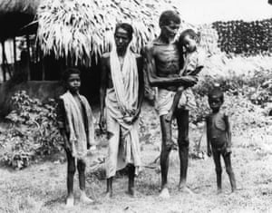](https://www.theguardian.com/world/2019/mar/29/winston-churchill-policies-contributed-to-1943-bengal-famine-study#img-4)

During a famine in Bihar in 1873-74, the local government led by Sir Richard Temple responded swiftly by importing food and enacting welfare programmers to assist the poor to purchase food.

FAMINE OF 1970

The first of these famines was in 1770 and was ghastly brutal. The first signs indicating the coming of such a huge famine manifested in 1769 and the famine itself went on till 1773. It killed approximately 10 million people; millions more than the Jews incarcerated during the Second World War.

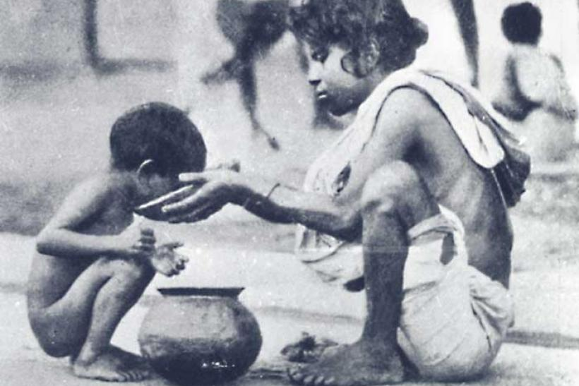

At the point when incomplete disappointment of harvests came in 1768, this wellbeing net was no longer set up. The downpours of 1769 were horrid and in this the primary indications of the awful dry season started to show up. The starvation happened for the most part in the advanced conditions of West Bengal and Bihar yet in addition hit Orissa, Jharkhand and Bangladesh. Among the most noticeably terrible influenced territories were Birbum and Murshidabad in Bengal.

The natural causes that had contributed to the drought were commonplace. It was the single-minded motive for profit that wrought such devastating consequences. No relief measure was provided for those affected.  
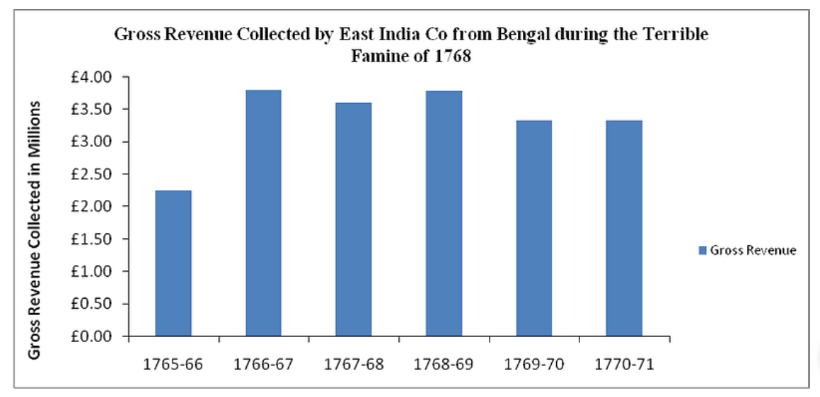  
Rather, as mentioned above, taxation was increased to make up for any shortfall in revenue. What is even more ironic is that the East India Company generated higher profits in 1771 than 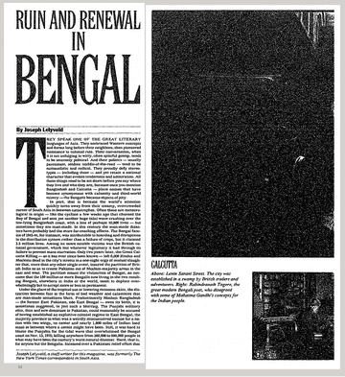they did in 1768

**DESCRIPTION**

Typically, the causes of a famine include supply side shocks including bad harvest, war time supply issues, which inevitably lead to rapid food price inflation. The causes of Bengal famine are much more complex and intertwined than just supply shortage.

In case of Bengal, the primary reason for the famine was shortages in Rice. A variety of factors led to the shortage, but most prominent among them was not supply shortage rather it was due to improper allocation of the available rice stocks. 1943 was a relatively bad year in terms of rice harvest (down 5% year-on-year), but not enough to cause a famine. What happened was a series of events which led to the disaster:

* A relatively bad harvest in winter crop of 1942, led to supply shortages.
* Occupation of Burma by Japan in 1942 resulted in restriction on rice imports from Burma.
* Restriction on inter-state trade of rice and other food grains at the time further aggravated the issue. This was lifted temporarily for eastern states but then put back again as the rice prices in other states also began rising.
* Hoarding of rice stocks by traders and farmers in anticipation of speculative rise in rice prices in future as rice shortage was becoming evident.
* No inaction on part of British authority to import more rice from abroad to control the situation.
* The event at the time was not declared as Famine, which would have allowed government to act on supplementary reserves. This was due to the fact that government didn’t have enough reserves to fulfill the demand.

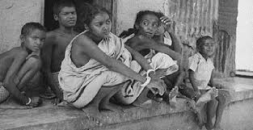

The brunt of the famine was most born by rural Bengal, primarily landless agricultural labour. The elite and some working class in Calcutta, however, remained largely untouched by the famine as the British government implemented a policy to provide rice at fixed price to close to one million workers in key factories, in order to not affect the war.

Ignorant policymakers within India and in the British Parliament combined with local inefficiencies were the major causes of Bengal famine of 1943, rather than supply shortage (supply in 1943 was the same as 1941, which did not experience any famine.

Lord Wavell, the then Viceroy, commented on British ignorance of the issue:

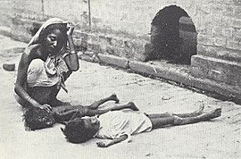“The vital problems of India are being treated by His Majesty’s Government with neglect, even sometimes with hostility and contempt.”

* After the [Battles of Plassey](https://byjus.com/free-ias-prep/ncert-notes-battle-of-plassey/) and Buxar, the British East India Company had acquired the Diwani rights over Bengal.
* The Nawab was only a nominal head with the real power resting under the company’s head.
* The company was only interested in maximizing revenue and profits for itself while the plight of the local farmers and others were completely neglected.
* Prior to the company’s rule, the tax rate on land revenue was only about 1/10th of the agricultural produce. But the company increased its overnight to 50% of the produce.
* The farmers, who had previously-stored excess produce for a lean season (they had excess because of the less tax), were not permitted to store produce, and they could not store too, because of the terrible tax regime under the English.
* 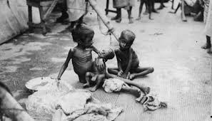The British forced farmers to harvest cash crops like poppy and indigo for export rather than food crops like paddy. This resulted in a shortage of grains for the people.
* There was a minor shortage of crops in 1768 which was not an alarming situation.
* But in 1769, there was a monsoon failure followed by severe [drought](https://byjus.com/free-ias-prep/droughts/). Starvation deaths started by 1769, but the company officials ignored this situation.
* By 1770, the death count was increasing and almost 10 million people fell victim to this man-made devastation.
* The company continued to collect taxes from farmers who could pay by further increasing the tax rate to make up for the loss in agricultural revenue due to the famine.
* This famine was caused, to a large extent, by the company’s tax and revenue policies, and apathy of the company officials to rising starvation.

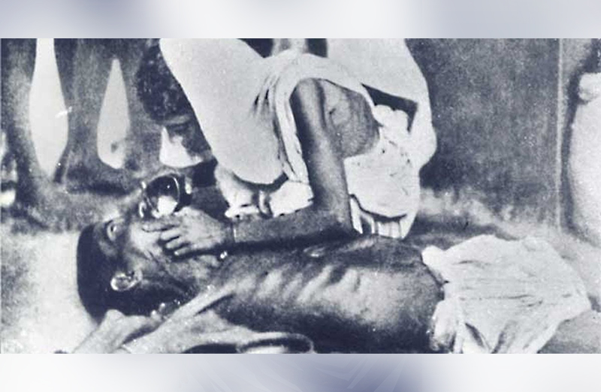

The famine would have far reaching consequences that would not only change the Indian subcontinent but even the world forever:

* The famine situation soothed by 1770 with good rainfall but not before claiming 1/3rd of the local population.
* Large swathes of land were depopulated as a result of the famine.
* Many agricultural lands became jungles for decades as a result of this famine.
* This also increased the menace of bands of [thugee or dacoits](https://byjus.com/free-ias-prep/thugee-and-dacoit-suppression-acts-1836-48/) in Bengal.
* Globally, the profit of the East India Company increased from fifteen million rupees in 1765 to thirty million in 1777.
* Despite the soar in profits, the company continued to suffer financially, and influenced Parliament to pass the Tea Act in 1773.
* The Act allowed direct shipment of tea to the American colonies, without the payment of taxes. This infuriated the local merchants to the extent that they began protesting against this measure. One such protest was the Boston Tea Party of 1773.
* The aftermath of the protest would eventually lead to a series of events that would culminate into the 1776 [American Revolution.](https://byjus.com/free-ias-prep/snapshot-on-causes-of-american-revolution-for-mains/)

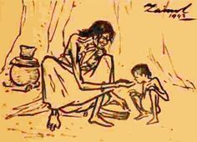

**MY OBSERVATION**

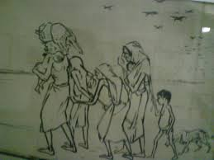Concerning Bengal Famines Of 1943 And 1970 Both Famines Are Dangerous Time for Bengal Because It is prominently known as Chhiyattarer Manvantar (The Great Famine of 1176 Bangla Year). It was the most noticeably terrible starvation in Bengal in the eighteenth century. The over the top precipitation in. The current income arrangement of land and exercises of go betweens in the food grain showcase further crumbled the circumstance.

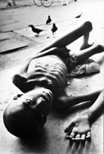The Great Bengal Famine of 1943 was one of the worst famines to have struck this region. A series of crop failures beginning from 1938 and other disruptive events accompanying the Second World War precipitated this famine. Interruption of normal imports of food grains from Burma due to its fall to the Japanese, dislocation of trade, irregular movement of food grains due to the war in the East, and building up of provincial and district barriers (cordons) against the movement of grains and other essential supplies, increased demand for food to meet the want of the army, and inflow of refugees were some important factors leading to the famine of 1943

**CONCLUSION**

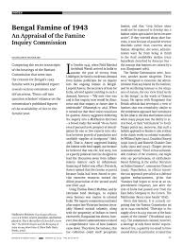Policy lapses such as prioritizing distribution of vital supplies to the military, civil services and others as well as stopping rice imports and not declaring Bengal famine hit were among the factors that led to the magnitude of the tragedy, historians have maintained. The 1943 Bengali famine was caused by then-British Prime Minister Winston Churchill’s policies and not drought.

The Bengal Famine of 1770 is one of the greatest catastrophes in modern times. As many as ten million people, a third of the entire population, died as a consequence. Drought, bad harvests and British economic and administrative policies all contributed to its catastrophic proportions.



**REFERENCE**



Safi, M. (2020). Churchill's policies contributed to 1943 Bengal famine – study. Retrieved 24 May 2020, from <https://www.theguardian.com/world/2019/mar/29/winston-churchill-policies-contributed-to-1943-bengal-famine-study>

Famine - Banglapedia. (2020). Retrieved 24 May 2020, from <http://en.banglapedia.org/index.php?title=Famine>

Chakraborty, R. (2020). The Bengal Famine: How the British engineered the worst genocide in human history for profit. Retrieved 24 May 2020, from <https://yourstory.com/2014/08/bengal-famine-genocide?utm_pageloadtype=scroll>

Real causes of the devastating Bengal famine, 1943. (2020). Retrieved 24 May 2020, from <https://medium.com/@Prakhar__Singh/real-causes-of-the-devastating-bengal-famine-1943-daac8389495e>

Bengal Famine of 1770 | Environment & Society Portal. (2020). Retrieved 24 May 2020, from <http://www.environmentandsociety.org/tools/keywords/bengal-famine-1770>

THE END